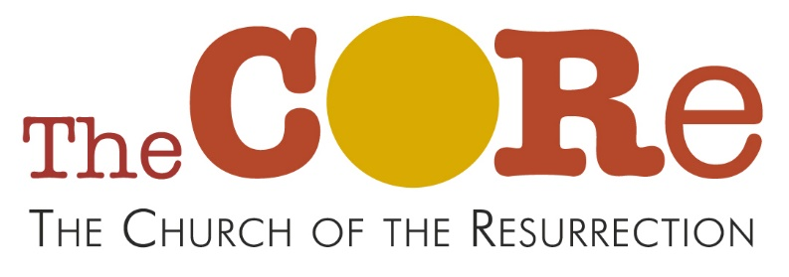
Churchway, SK10 3HT
Easter Fun Afternoon
Saturday 28th March 2-4pm
Crafts, stories and games to help children understand Palm Sunday & Easter
For children aged 5-11, accompanied by a parent or responsible adult.
Crafty activities will be messy so old clothes are a good idea.
All free. Places are limited.

Please register your child/children using the form on page 2

Page 1
Registration Form
CORE Easter Fun Afternoon, 28/3/26 at 2-4pm

Name and age(s) of child / children

Name of accompanying parent / responsible adult

Contact tel number:

Email address if possible:

Any allergies / food intolerances / health issues we should be aware of?

Please put a cross in the box if you are happy for us to save this information for the purpose of administering this event

I give my permission for my child to attend this event
Signature of parent:

Please return this form to the Upton Priory School Office, or scan and email to core.upton@gmail.com, or post into the church letterbox. Thank you.

Page 2

